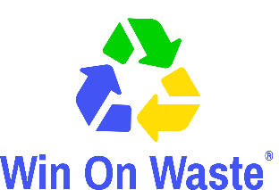
‘We Need That!’/Decluttering? We Need That!

NEEDS CONTACT FORM FOR INDIVIDUALS
Please return with a copy of your List of Needs

The following details will appear in the booklet.

[please type or print]
Your name
Contact phone number
Email (only if you wish)
Town & ward you live in

Please tell us which charity you are collecting the items for:

For office use only [please only complete if you have not added an email address to the above].

Email

Important
To help us with our monitoring and evaluation of the project, please keep a note of any items you receive as a direct response from appearing in the We Need That! booklet and ask how the donor first heard about it. Thank you.

By completing this form and appearing in the booklet I agree that:
- The item(s) I request will be used by me for my personal use (or on behalf of a not-for-profit group). The item(s) will not be used as a profit-making venture, unless the profits are donated to charities or other not-for-profit organisations.
- I will be responsible for the delivery or collection of items from donors.
- Win on Waste accepts no liability or responsibility in relation to the delivery and/or collection of items. Win on Waste is only facilitating in the brokerage of reusable items.

Please return forms via email to contact@winonwaste.org in the first instance. If returning forms by post please send to Stacey Woods, Win on Waste c/o Community Action Network, Floor 3, Beech House, 28-30 Wimborne Road, Poole BH15 2BU

