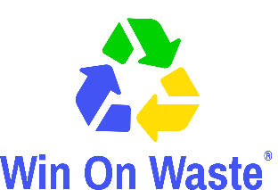
‘We Need That!’/Decluttering? We Need That!
NEEDS CONTACT FORM FOR NOT-FOR-PROFIT ORGANISATIONS
Please return with a copy of your List of Needs

The following details will appear in the booklet.
[please type or print]
Organisation name:
Name of contact:
Address:
Email:
Phone No:
If your main contact details are different to the above (these won’t be used in the booklet) then please add them below:

Name of contact:
Address:
Email:
Phone No:

Important
To help us with our monitoring and evaluation of the project, please keep a note of any items you receive as a direct response from appearing in the We Need That! directory and ask how the donor first heard about it. Thank you.

By completing this form and appearing in the booklet we agree that:
- The items we request will be used by us within our organisation, or to help us with our fundraising.
- We will be responsible for the delivery or collection of items from donors.
- Win on Waste accepts no liability or responsibility in relation to the delivery and/or collection of items. Win on Waste is only facilitating in the brokerage of reusable items.

Important
To help us with our monitoring and evaluation of the project, please keep a note of any items you receive as a direct response from appearing in the We Need That! booklet and ask how the donor first heard about it. Thank you.

By completing this form and appearing in the booklet I agree that:
- The item(s) I request will be used by me for my personal use (or on behalf of a not-for-profit group). The item(s) will not be used as a profit-making venture, unless the profits are donated to charities or other not-for-profit organisations.
- I will be responsible for the delivery or collection of items from donors.
- Win on Waste accepts no liability or responsibility in relation to the delivery and/or collection of items. Win on Waste is only facilitating in the brokerage of reusable items.

Please return forms via email to contact@winonwaste.org in the first instance. If returning forms by post please send to Stacey Woods, Win on Waste c/o Community Action Network, Floor 3, Beech House, 28-30 Wimborne Road, Poole BH15 2BU

