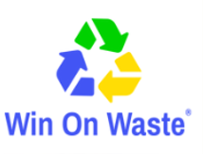
‘We Need That!’ Directory
Form for Individuals or Organisations Collecting Unwanted Items

Items Requested (please give as much detail as possible including any timescales involved) | Use of Item (eg will it be recycled for fundraising or reused in anyway)

The following details will appear in the booklet.
Organisation name:
Name of contact:
Address:
Collection/Drop off Details: (eg opening hours)
Email:
Phone No:
If your main contact details are different to the above (these won’t be used in the booklet) then please add them below:
Name of contact:
Address:
Email:
Phone No:

To help us with our monitoring and evaluation of the project, please keep a note of any items you receive as a direct response from appearing in the We Need That! directory and ask how the donor first heard about it. Thank you.

By completing this form and appearing in the booklet you agree that:
- The items you request will be used by you within your organisation, or to help with fundraising.
- You will be responsible for the delivery, collection or drop off of items.
- Win on Waste accepts no liability or responsibility in relation to the delivery and/or collection of items. Win on Waste is only facilitating in the brokerage of reusable items.

Please return forms via email to volunteers@winonwaste.org.

